Noah Foilb

ASQ Findings

**Relationship between family’s ability to pay vs their grant**

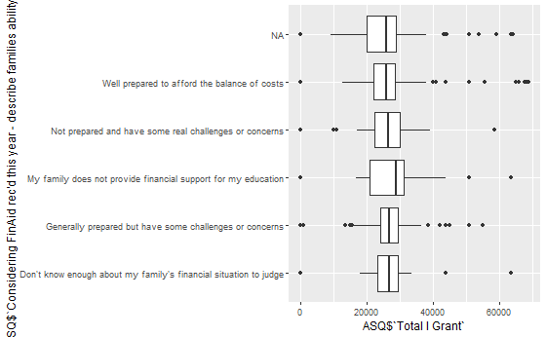

**Relationship between your ability to pay vs your grant**

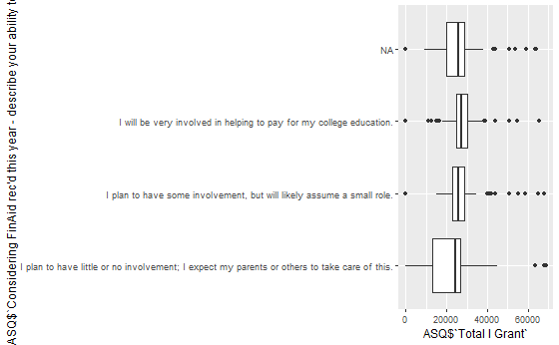

**Decision vs Enrollment**

0 1

I do not plan to attend college this fall 128 0

I plan to attend a college other than Merrimack College 784 2

I plan to attend college this fall, but I still don't know where 39 3

I plan to attend Merrimack College 35 507

**Family Status vs Enrollment**

0 1

Don't know enough about my family's financial situation to judge 25 13

Generally prepared but have some challenges or concerns 196 137

My family does not provide financial support for my education 30 11

Not prepared and have some real challenges or concerns 51 46

Well prepared to afford the balance of costs 85 65

**Self-status vs Enrollment**

0 1

I plan to have little or no involvement; I expect my parents or others to take care of this. 37 35

I plan to have some involvement, but will likely assume a small role. 182 117

I will be very involved in helping to pay for my college education. 166 117

**Zip Code Talking Points**

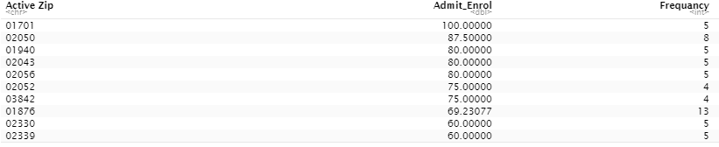Please note that frequency is the number of students per zip code in the ASQ Dataset. As the ASQ dataset is fairly small, the variability of such information is high as we do not have enough data to back such finds.